PATIENT INFORMATION

Looking after your fractured foot

Tennis (Lateral) Elbow Release

What are the risks of having a Tennis Elbow Release?
All operations involve an element of risk, these are very small but you need to be aware of them and can discuss them with your doctor at any time.
The risks are:
- Complications relating to the anaesthetic
- Infection
- Persistent symptoms - the operation is said to be successful in approximately 80% of patients.

What is a Tennis (Lateral) Elbow Release? What am I having done?
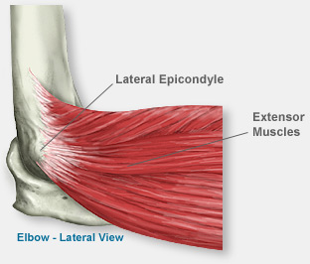
Tennis elbow is the name used to describe pain on the outside of the elbow in the area of the lateral epicondyle (see picture) i.e. the bony prominence on the outside of your elbow. Tennis elbow is believed to be caused by overuse of one or more of the tendons that attach onto the lateral epicondyle.
The exact cause of tennis elbow is not known, but it is believed to result from overuse of these tendons such as in tennis (hence the name) and happens mostly in patients between the ages of 40 – 50 years.
A Lateral Release of the Elbow involves a small incision over the lateral epicondyle area and separation of the common tendon origin from the lateral epicondyle. This aims to relieve pressure and strain on the tendon.

What is the Aim of Surgery? Why am I having it?

The main aim of Tennis Elbow Release is to reduce pain and therefore to improve function (your daily activities that you may have difficulty with).

What are the risks of surgery? What do I need to look out for?
All operations involve an element of risk, these are very small but you need to be aware of them and can discuss them with your doctor at any time. The risks are
- Complications relating to the anaesthetic
- Infection
- Nerve damage
- Persistent symptoms - the operation is reported to be successful in over 70% of patients.
If you suffer a sudden increase in pain, onset of pins and needles and /or numbness or start to feel unwell and hot you must be reviewed by your doctor at the earliest opportunity.

What Should I expect after the operation?

Remember that you have just had an operation. It is normal to feel more tired than usual for a few days after having an operation. Your elbow is likely to be uncomfortable in the first few days post-surgery. This is normal.

How can I help myself to recover?
There are several things you can do to aid your recovery and help to settle any postoperative pain.
- Using ice on your elbow for 10 minutes, 2 times per day or after exercise and therapy. Gel packs, frozen peas or a plastic pack of ice can be used. These must be wrapped in a moist towel as direct contact with the skin can cause burns (cover your dressings with cling film or a plastic bag to prevent them getting wet).

- Sleeping can be uncomfortable if you try and lie on your operated arm. We would recommend that initially you lie on your back or on the opposite side. If you lie on your back support the operated arm with a folded pillow under your lower arm, with the arm in your sling. Make sure that your elbow is always in front of your shoulder. If you are on your side then a folded pillow supports your operated arm from your elbow to your wrist.
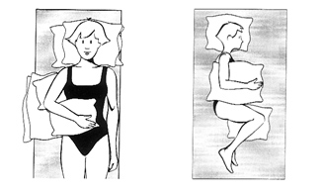

How long will it take for me to recover?

Patients having this procedure will usually experience a significant improvement in symptoms within 6-12 weeks of surgery but will improve for potentially 6 to 9 months post surgery.

When can I return to work?

Return to work is dependent on the nature of your work and how quickly your pain settles. This must be discussed with your surgeon or physiotherapist however the following are a guideline;

Sedentary work – 1-6 weeks

Manual work – 6 weeks

When can I return to driving, hobbies etc?

You can usually begin driving between 1 and 6 weeks after your operation if you feel comfortable. However it is essential that you discuss this with your surgeon or physiotherapist and inform your insurance company that you have had elbow surgery.

Swimming- 3- 6 weeks*

Golf / Tennis- 6-12 weeks*

* These timescales are only a guide. Each patient is an individual and their physiotherapist and surgeon will advise them depending on their individual rate of progress, pain level and muscle control.

When will I go back to see the doctor?

You will be reviewed in the consultant’s clinic following your surgery.

Physiotherapy Appointments - How often will I have to attend?

It is essential to your recovery to attend physiotherapy as directed by your physiotherapist. You have an important part to play in your own recovery and therefore will be expected to follow your home exercise programme as instructed.

With Thanks to
The Upper Limb Team
Royal Liverpool & Broadgreen Hospitals

